Bahria University,

Karachi Campus



CLASS: BSE- 3 (B)

Flappybird (Game)

Project Report

Engr. Noor us Sabah / Engr. Ramsha Mashood

Signed Remarks: Score:

**Group Members:**

* + - Zain Shahid(Leader) (02-131222-032)
    - Aneesha Kumari (02-131202-052)
    - Khizra Tariq Syeda (02-131202-001)

**Table of Contents**

**1.** **INTRODUCTION & PROBLEM** 2

**2.** **TECHNOLOGY** 3

**3.** **FUNCTIONALITIES** 3

**4.** **MODULE DISTRIBUTION:** 3

**5.** **CODE:** 4

**6.** **INTERFACES:** 12

**7.** **CONCLUSION:** 14

1. **INTRODUCTION & PROBLEM:**

Flappy Bird is an arcade-style game in which the player controls the bird, which moves persistently to the right. The player is tasked with navigating the bird through pairs of pipes that have equally sized gaps placed at random heights. It automatically descends and only ascends when the player taps the ‘f’ button on the keyboard.

1. **TECHNOLOGY:**

We used Mars simulator for our project. We made our project on bitmap of MIPS Assembly language.

1. **FUNCTIONALITIES:**

In our game, the image moving is the most important function we need to implement. Besides the background horizontal moving, the vertical jumping combining keyboard input is our second challenge. The bird briefly flaps upward each time the player taps the ‘f’ button; if the button is not tapped, the bird falls due to gravity.

# **MODULE DISTRIBUTION:**

**Zain Shahid:**

Implementation of pipe, coding of top refresh and bot refresh.

**Aneesha Kumari:**

Coding of bird, using loop and method of jump.

**Khizra Tariq Syeda:**

Designing of bitmap display, coding of reset of game and exit screen.

# **CODE:**

# **INTERFACES:**

We used bitmap display for the output of the program. To control the movements of the bird we used a keyboard simulator. The background, the pipes and the bird as well as their movements with respect to the bird and the keys entered are the most significant part of the game.

**Output:**

**Bitmap Display:**

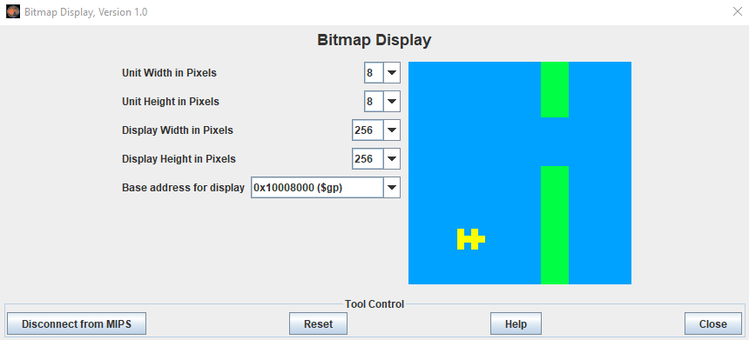

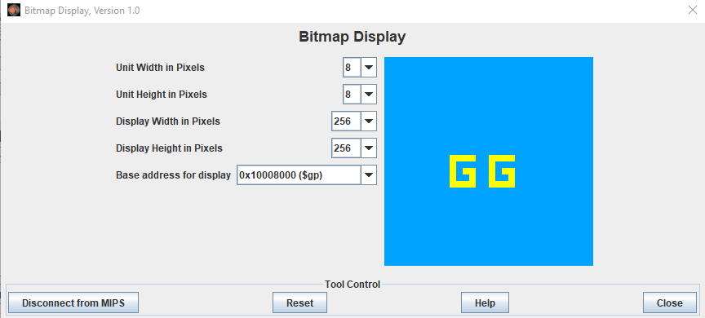

**Keyboard Simulator:**

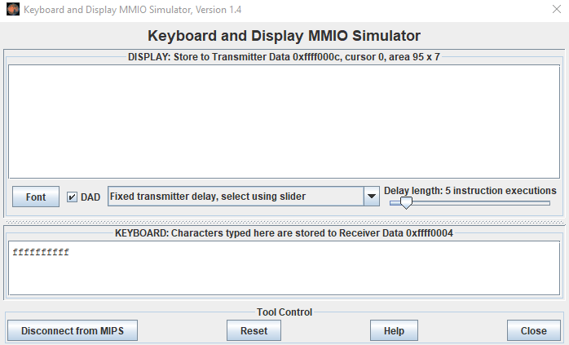

# **CONCLUSION:**

Flappybird is a simple game of the infinite level type. People of almost every age can play this game. It can be played in their leisure time for entertainment. It is also an easy-to-play game which does not require any complex procedure to play it. It is an addictive game and a person can play it for hours. It is possible to play this game on android.